**Project Documentation**

My sleep tracker has a functional dashboard, sleep data page, quality of mood page and profile page, the sign out page is non-functional as I was instructed it wasn’t needed.

My page has 3 predefined data that is present by default as per your suggestion, and they reflect in every page, the screenshots are provided below:

This is the main dashboard with default data, only current week’s data is displayed in this page

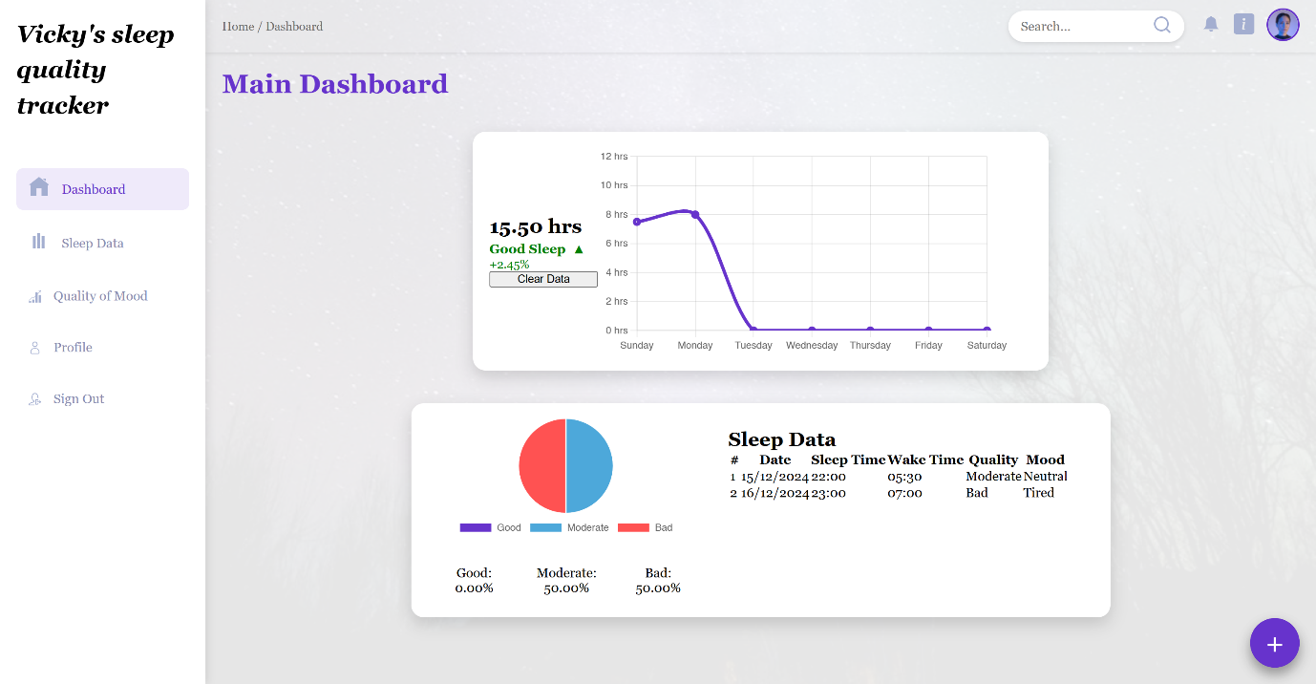

This is the main dashboard after all data has been cleared by using the clear data button

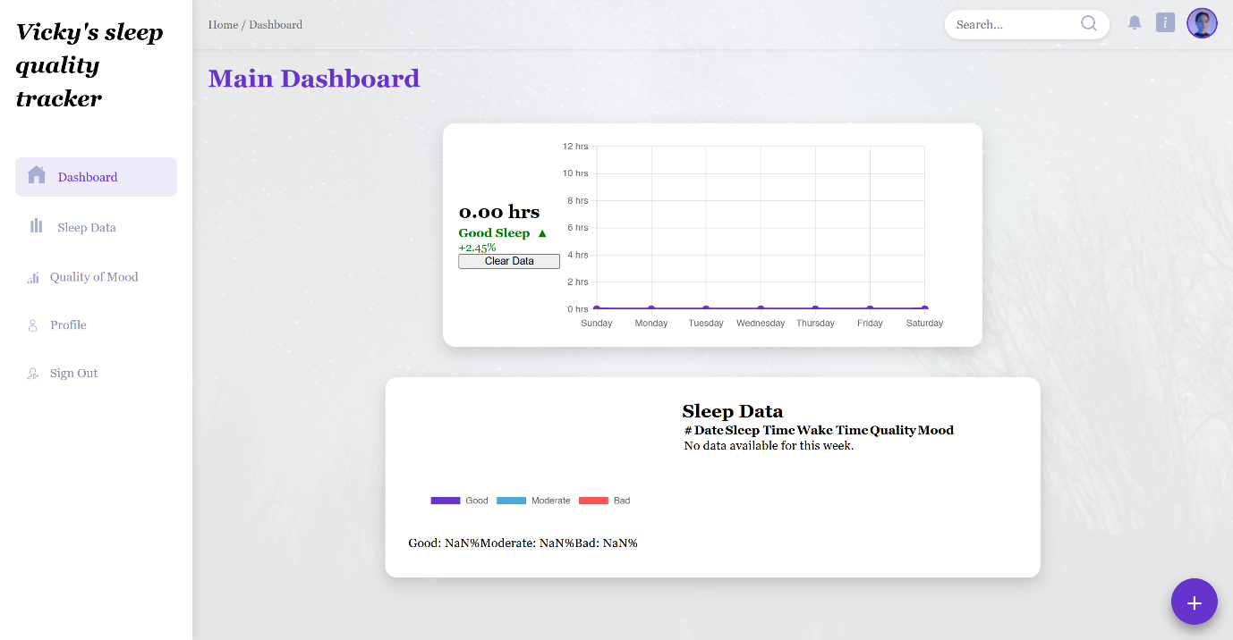

This is the pop-up that enables users to add sleep data

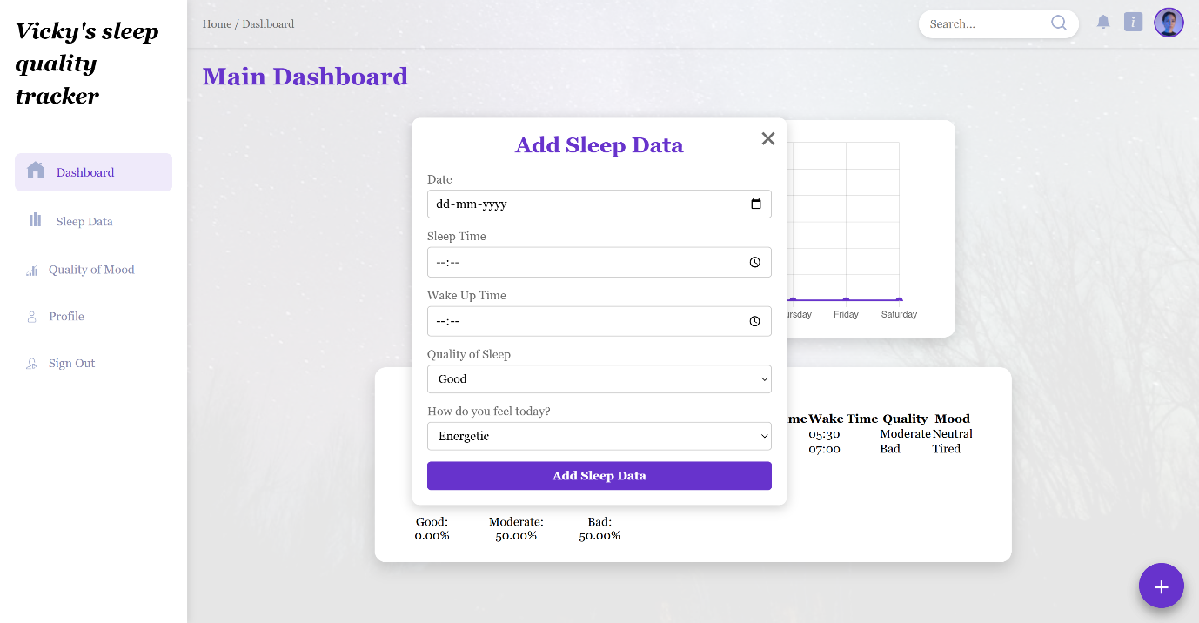

This is the sleep data page with default data, only current week’s data is displayed here

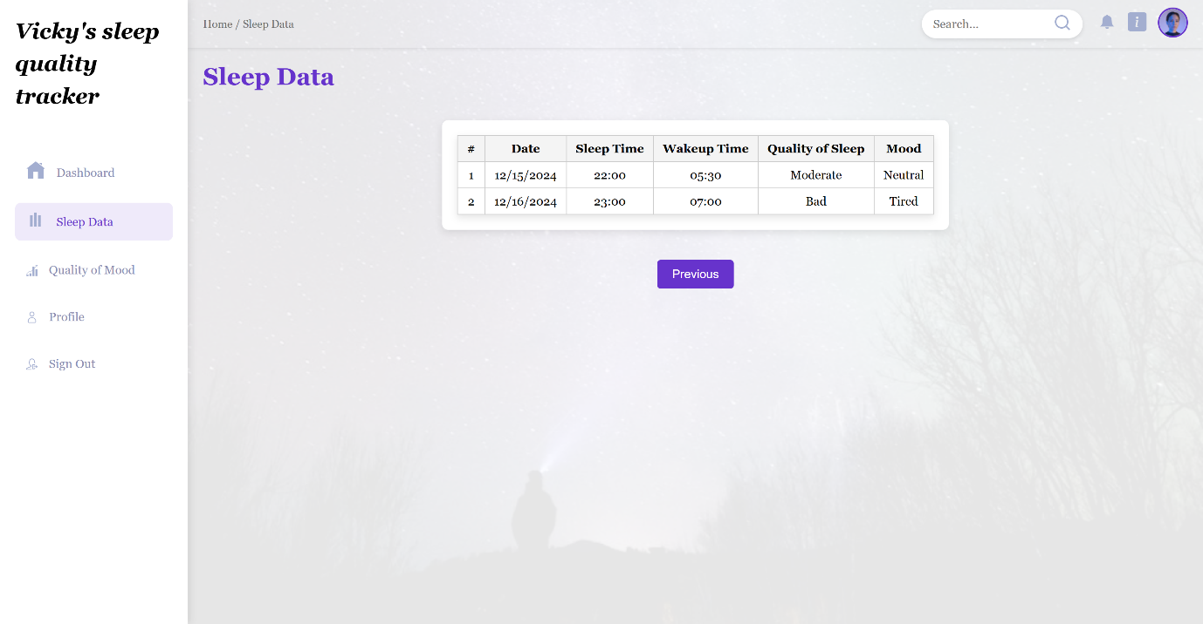

After using the previous button, the previous week’s data is displayed as below

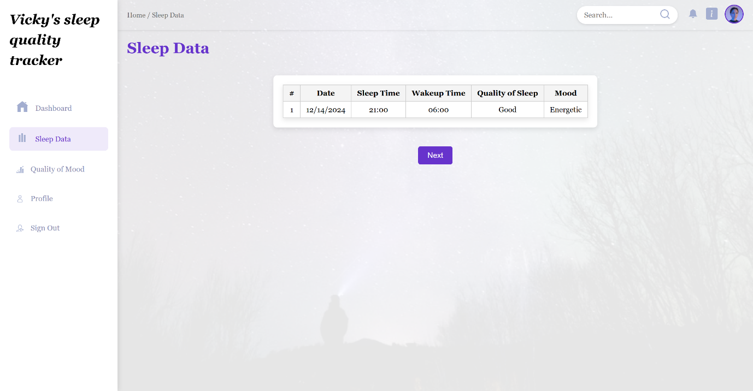

This is the quality of sleep and mood page with default data. Only current week data is displayed here.

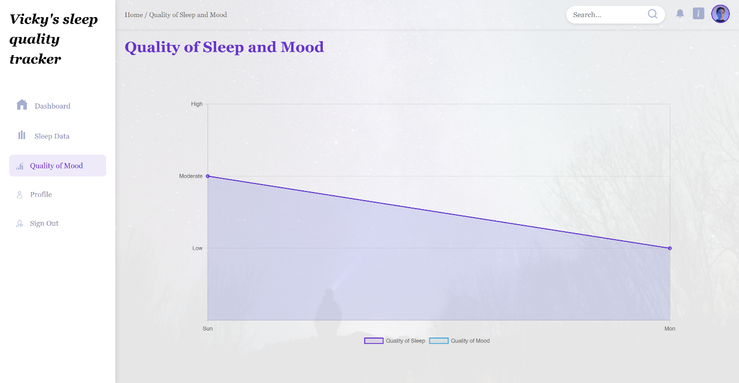

This is the static profile page

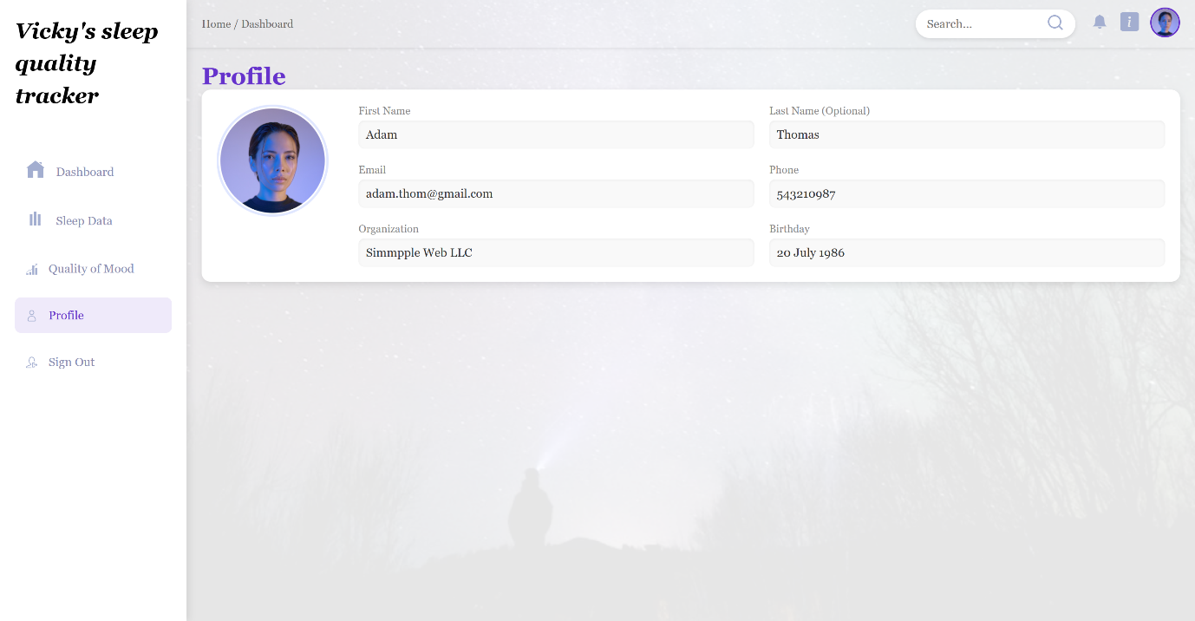

After populating the page with data, this is how it’ll look:

This is the main dashboard with input data, only current week’s data will be displayed in this page

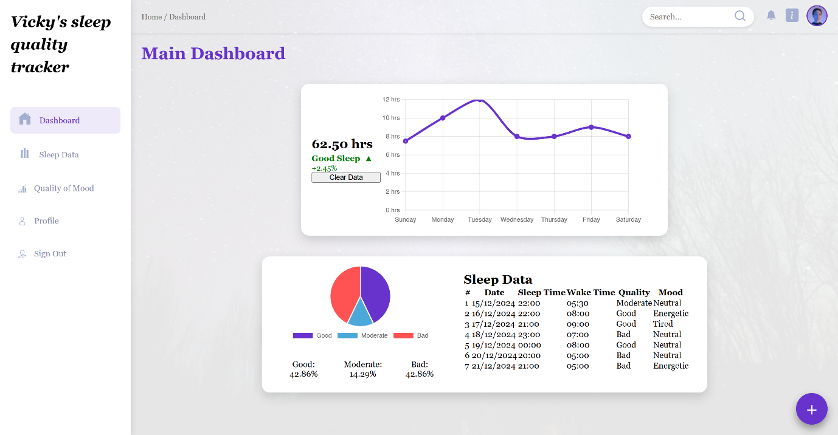

This is the sleep data page with input data, only current week’s data is displayed here

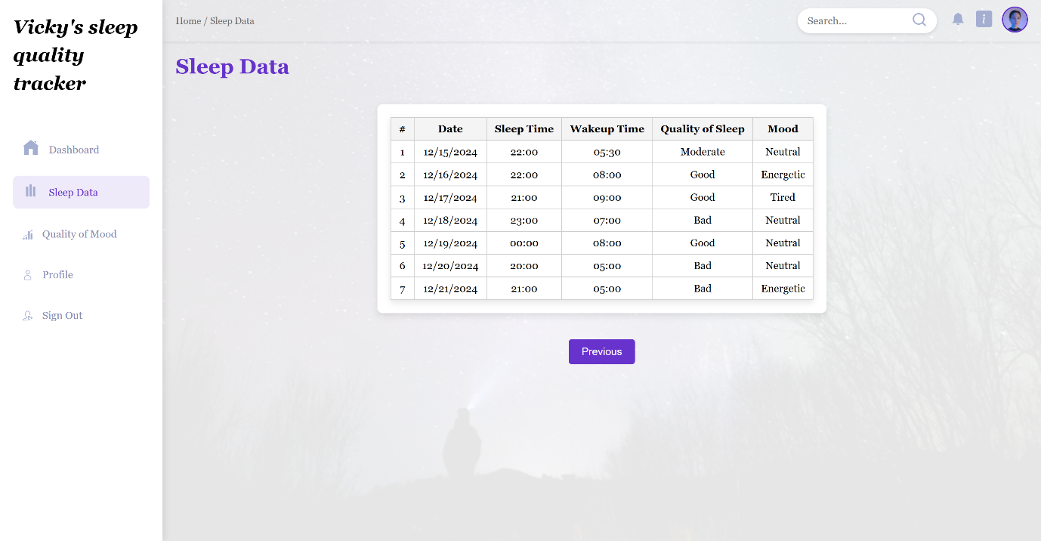

This is the quality of sleep and mood page with input data. Only current week data is displayed here.

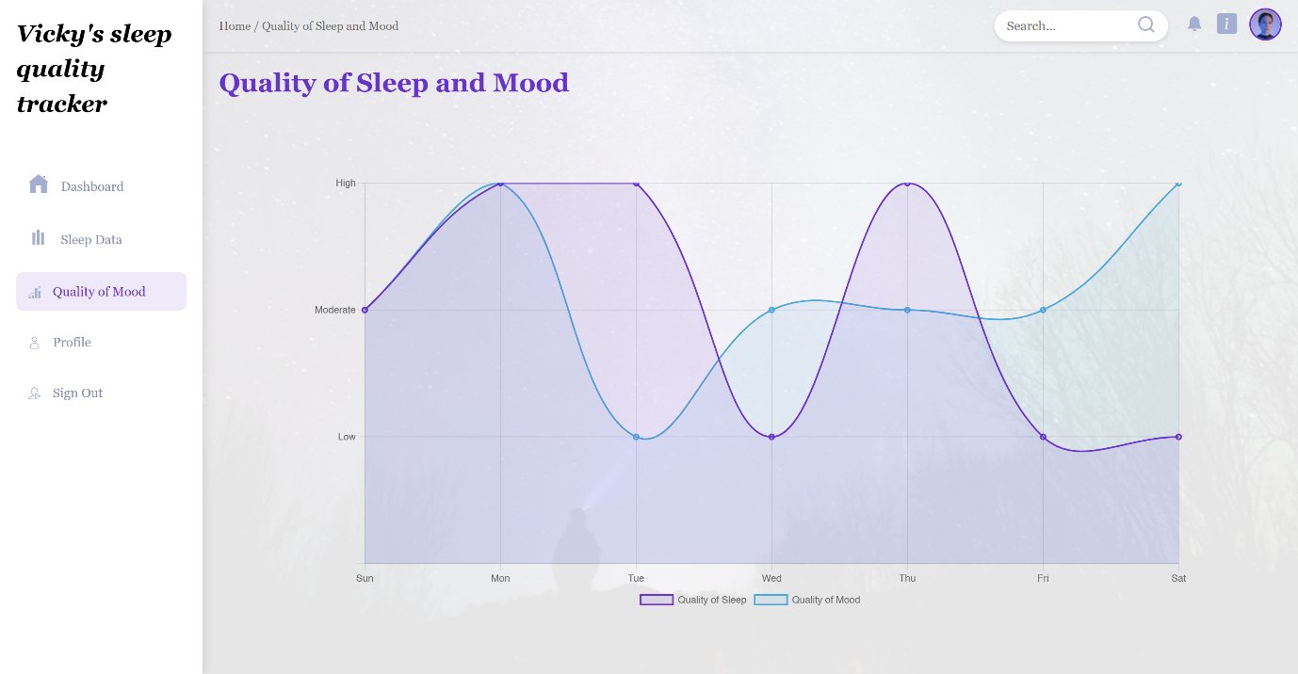

The quality of sleep and mood page also displays the “best sleep nights” data, which is the days with a good sleep quality

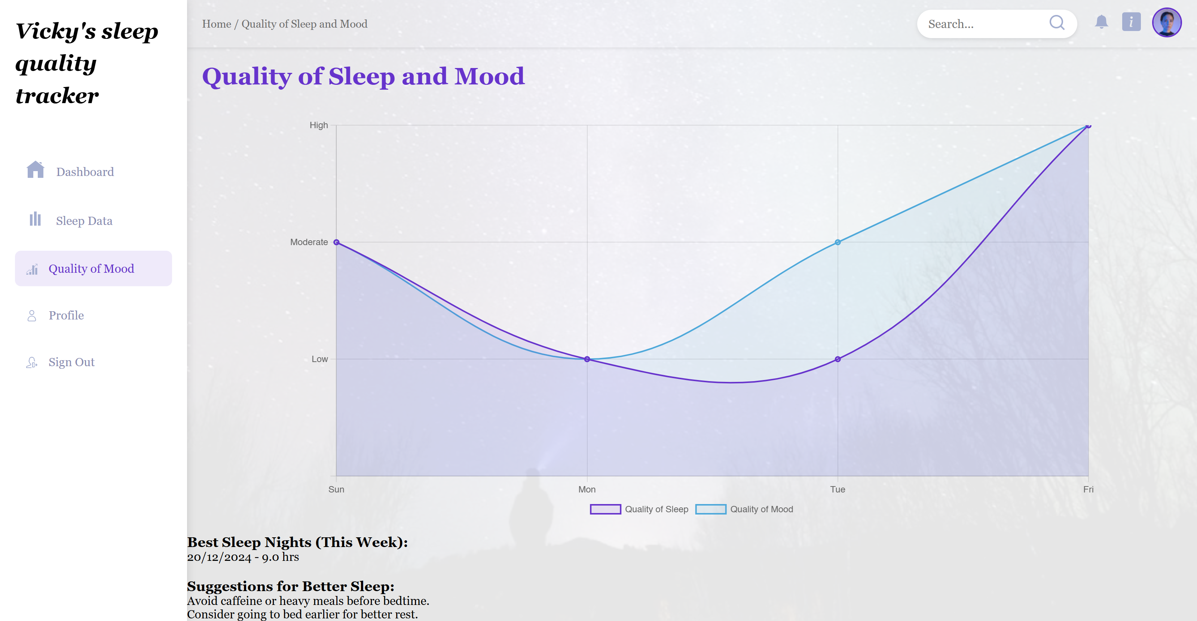

**Key pointers:**

* While adding data by selecting a particular date, the sleep data will be updated for the previous day. This is because, we can only enter current day’s sleep data the next morning.
* The input for time is taken in 24 hours format.
* We have only provided the capability to view sleep hours up to 12 hours in the graph assuming that it would be the maximum hours of sleep for an average person.
* The previous and next button in the sleep data page will only show up if there are data for previous week or current week.
* The sleep indicators in the main dashboard page are static since we don’t have enough data to determine it as of now.

**Future enhancements:**

* Sleep indicators to display accurate information dynamically based on historical data.
* Sign-in and sign-out features.
* The ability for the user to choose the span of time for graph display.

**References:**

<https://www.w3schools.com/ai/ai_chartjs.asp>

<https://www.chartjs.org/docs/latest/getting-started/>

<https://www.chartjs.org/docs/latest/getting-started/usage.html>

<https://www.tutorialspoint.com/chartjs/chartjs_syntax.htm>

<https://www.tutorialspoint.com/chartjs/chartjs_color.htm>

<https://www.tutorialspoint.com/chartjs/chartjs_options.htm>